PROJECT REPORT
ON
From BI to Big Data: Explain, Design & Defend

Subject Name: Big Data Analytics
Subject Code: BAD601
Submitted By: Sumit Kumar Gupta Submitted To:
USN: 1AY23CD060 Ms. Surbhi

Contents
TaskNo. | Task | Page No  .
1 | Big Data in Daily Life – Visual Storytelling | 3
2 | BI vs Big Data Play | 4 - 5
3 | Architecture Design Challenge | 6
4 | Analytics & Tool Match | 7

5 Bonus Challenge - Big Data Explainer 8

Task 1:
Big Data in Daily Life – Netflix Visual Storytelling
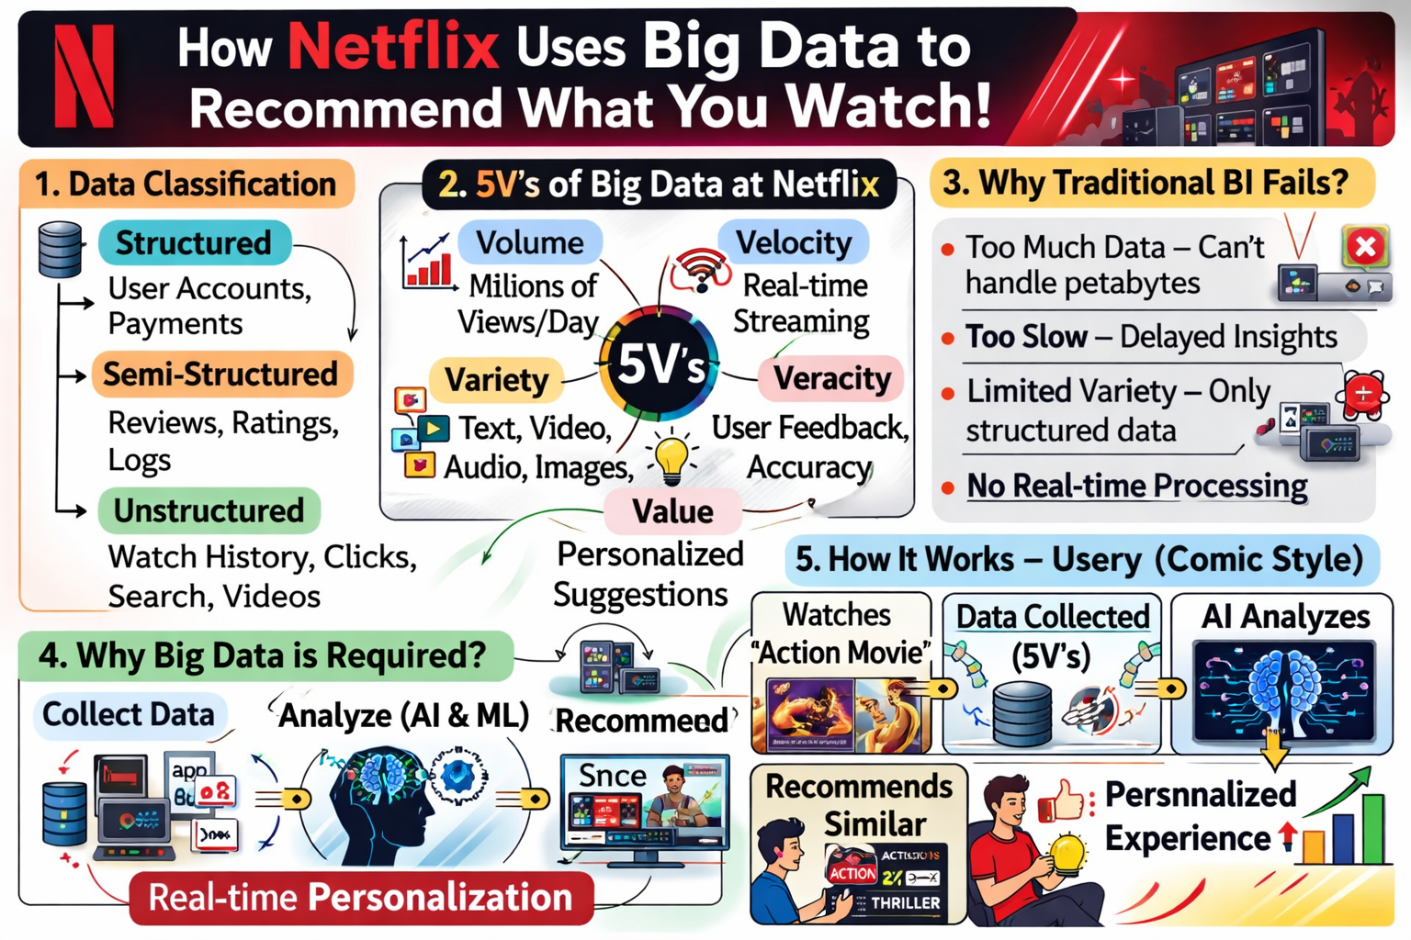
Task 2:
Strategic Dialogue-BI and Big Data Play

Manager: I’ve used Excel and SQL for 10 years. Our sales reports are fine. Why disrupt this?

Consultant: Our sales reports show the past. We need to see the future. SQL is hitting a scaling wall.

Manager: Can’t we just buy a bigger server?

Consultant: That’s Vertical Scaling. It’s like building a skyscraper on a weak foundation. Big Data is Horizontal Scaling—adding more cheap floors side-by-side.

Manager: What changed? We didn’t need this five years ago.

Consultant: The Evolution. Data grew from Giga to Peta. Social media, sensors, and video logs changed the game.

Manager: SQL manages data just fine, though.

Consultant: Only if the data is “clean.” Big Data uses Schema-on-Read. We store the raw chaos first and define meaning only when we need to.

Manager: Hadoop... isn’t that just a storage bin?

Consultant: It’s a distributed engine. It breaks data into pieces and processes them in parallel across a cluster.

Manager: And NoSQL? I’ve heard it’s unstable.

Consultant: It’s flexible. It handles Variety (images/logs) that your SQL database would choke on.

Manager: My team takes days to generate a report.

Consultant: With Spark, we process in-memory. Those days turn into seconds.

Manager: Give me the ROI. Why spend the money?

Consultant: Churn prediction. We identify an unhappy user before they cancel. That saves millions.

Manager: And the marketing aspect?

Consultant: Hyper-personalization. We recommend products based on behavior, not just history.

Manager: Okay. Let’s move beyond the spreadsheet. What’s the plan?

Task 3:
Architectural Design Analysis

3.1-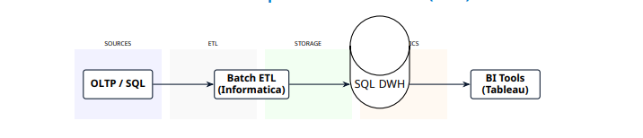Architecture A: Traditional Enterprise Data Warehouse (EDW)

3.2-
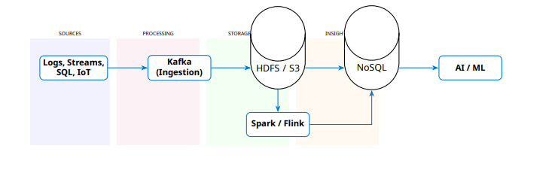 Architecture B: Modern Big Data Ecosystem (Lambda Pattern)
Task 4:
Analytics & Tool Strategic Match

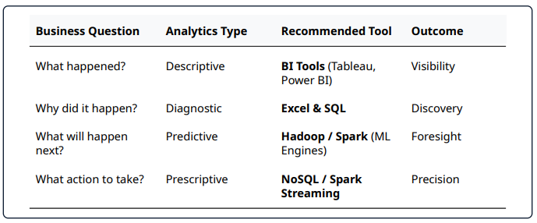

Task 5:
Bonus Challenge - Big Data Explainer
Imagine a candy jar as tall as a skyscraper! It has billions of pieces of candy—chocolates, gummies, and lollipops—all mixed together. This giant, messy pile is "Big Data."
Problem If you wanted to find one specific blue gummy bear by yourself, it would take you 100 years to look through that giant jar! You are just one person, and the jar is too big.

Solution (The "Big Data" Magic)
Big Data is like having a Million Tiny Robots that you control. When you shout: "Find the blue gummy!" every robot flies to a different part of the jar at the exact same time.

Result
Because they all work together at once, they check every single piece of candy in the whole skyscraper in less than a second. They find your gummy and bring it to you instantly!

